PRESS RELEASE
ITE HCMC 2026 ENTERS THE FINAL COUNTDOWN,
READY TO HOST VIETNAM’S LARGEST INTERNATIONAL TRAVEL EXPO TO DATE
More than 520 exhibitors, 260 international buyers, 21,000 pre-scheduled B2B appointments, three regional Tourism Ministers’ Conferences, a series of forums featuring leading global tourism organizations and corporations, and three days of public experiences
Ho Chi Minh City, August 2026 – With less than three weeks to go before its opening, the 20th Ho Chi Minh City International Travel Expo (ITE HCMC 2026) has completed preparations and is ready to welcome its largest edition since its inception in 2005. Marking two decades of growth and development, ITE HCMC 2026 will not only be the Expo’s largest edition to date, but will also reaffirm its position as one of Vietnam’s leading platforms for international tourism trade promotion and cooperation, supporting the country’s global integration, destination promotion and the continued elevation of Vietnam’s tourism profile on the international stage.
Taking place from 27–29 August 2026 at the Saigon Exhibition and Convention Center (SECC) in Ho Chi Minh City, under the theme “Vibrant Connections – Global Destinations,” ITE HCMC 2026 is organized under the direction of the Ministry of Culture, Sports and Tourism and the People’s Committee of Ho Chi Minh City. The Expo is jointly organized by the Vietnam National Authority of Tourism and the Ho Chi Minh City Department of Tourism, with the Ho Chi Minh City Tourism Promotion Center, C.I.S Vietnam Advertising & Exhibition Joint Stock Company, and relevant agencies and organizations directly involved in its implementation.
For its 20th edition, ITE HCMC 2026 is expected to bring together more than 520 exhibitors and brands, 34 provinces and cities, 260 high-level international buyers from more than 40 countries and territories, approximately 600 international delegates, 50 high-level delegations, more than 21,000 pre-scheduled B2B appointments, around 30,000 visitors, and 60 international media outlets.
20 YEARS OF ADVANCING THE GROWTH OF HO CHI MINH CITY AND VIETNAM
First held in 2005, ITE HCMC has evolved from a regional trade event into one of Vietnam’s leading platforms for international tourism trade promotion. Over the past 20 years, the Expo has brought together government agencies, localities, tourism businesses and international partners, contributing to the promotion of Vietnam’s image, strengthening inter-regional connectivity, expanding international cooperation and creating new momentum for tourism growth.

Beyond its expanding scale, ITE HCMC has generated tangible opportunities for collaboration, serving as a catalyst for new tourism linkages and products, cooperation agreements and investment opportunities, thereby contributing to the competitiveness of Vietnam’s tourism industry.
A notable milestone in the development of ITE HCMC 2026 is its strong implementation of the policy of mobilizing social resources and leveraging the effectiveness of public-private partnerships in event organization. In line with this direction, the Expo has strengthened engagement with and mobilized support from businesses, airlines, organizations and partners both domestically and internationally. These partnerships have provided additional resources for the organization of the Expo while enhancing the quality of B2B networking, international buyer hosting and professional programs.
The collective support of the business community not only contributes to the success of ITE HCMC 2026, but also demonstrates the Expo’s broader role in connecting and mobilizing resources across society, while driving the development of tourism in Ho Chi Minh City and Vietnam.
The 20th-anniversary milestone also marks the most significant expansion in the Expo’s history. During its initial period from 2005 to 2010, ITE HCMC brought together approximately 210 exhibitors and brands, 120 international buyers from 18 countries and territories, and more than 3,200 B2B appointments. By 2026, the Expo is expected to welcome more than 520 exhibitors and brands, 260 international buyers from more than 40 countries and territories, and over 21,000 pre-scheduled B2B appointments.
Notably, the number of B2B appointments has increased by more than eightfold compared with the Expo’s early years, underscoring the growing appeal and effectiveness of ITE HCMC as a business networking platform for the domestic and international tourism community.

260 INTERNATIONAL BUYERS – A DISTINCTIVE VALUE THAT DEFINES THE ITE HCMC BRAND
- One of the defining strengths of ITE HCMC over the past two decades lies not only in its scale, but also in its Hosted Buyers Programme – a professional tourism trade promotion initiative that remains the only program of its kind in Vietnam to systematically select, invite and host qualified international tourism buyers with genuine business needs and the potential to generate commercial transactions beyond the Expo.
- In 2026, the Hosted Buyers Programme is expected to bring together 260 high-level international buyers from Northeast Asia, Southeast Asia, South Asia, the Middle East, Europe, North America and Oceania. They represent leading global tourism groups, companies and organizations, including TUI Group, DERTOUR, Travco Corporation, American Express Global Business Travel (AMEX GBT), Flight Centre Travel Group, Thomas Cook, Trip.com Group, Education First (EF), Luxury Escapes, DidaTravel, FCM Travel India, Uniworld Boutique River Cruises, Ignite Travel Group, Goway, Remote Lands, Collette, BCD Meetings & Events, HelmsBriscoe, Fora Travel, Travel Edge, MCI Group, and more.
To maximize the effectiveness of business networking, the Organizing Committee has completed the international buyer selection process and pre-scheduled appointments across the full business connection program, including:
✔ Buyers - Sellers Speed Dating – taking place on the morning of 26 August 2026, ahead of the Opening Ceremony. The session provides international buyers and exhibitors with an opportunity to quickly identify potential partners and establish initial connections before entering the official business meetings.
✔ B2B Business Matching – taking place on 27 and 28 August 2026, with more than 21,000 B2B appointments pre-scheduled based on each business’s product portfolio, target markets and specific partnership needs.
✔ Pre- & Post-Tours – destination familiarization programs for international buyers and media before and after the Expo, providing destinations with opportunities to showcase their tourism products, services and attractions directly to international partners through first-hand experiences.

THE LARGEST AND MOST COMPREHENSIVE EXHIBITION ECOSYSTEM TO DATE

Entering its 20th edition, ITE HCMC 2026 brings together the most comprehensive and diverse tourism ecosystem in the Expo’s history, featuring more than 520 exhibitors and brands, alongside the participation of leading National Tourism Organizations (NTOs) such as the Korea Tourism Organization (KTO) and the Japan National Tourism Organization (JNTO), as well as tourism promotion agencies from Malaysia, Thailand, Laos, Cambodia, Bhutan, Saint Petersburg (Russian Federation), Nicaragua, and numerous other international partners.

The Expo also brings together 34 provinces and cities across Vietnam, alongside leading companies from the travel, accommodation, aviation, transportation and travel technology sectors.

More than an exhibition space, ITE HCMC 2026 serves as a comprehensive tourism trade platform, providing businesses with opportunities to showcase their products, connect with potential partners, gain insights into emerging tourism trends and expand international cooperation.

ITE HCMC 2026 – MORE THAN AN EXPO: A PLATFORM FOR REGIONAL TOURISM COOPERATION AND POLICY DIALOGUE

Going beyond its role as a tourism trade promotion event, ITE HCMC 2026 continues to strengthen its position as an influential regional platform for tourism cooperation, policy dialogue and knowledge exchange across the Asia-Pacific.

The concurrent organization of high-level diplomatic engagements, a series of industry forums and business networking programs creates a unique space where policy-making, trade promotion and innovation converge – a distinctive value proposition that few tourism trade events in the region can offer.

By bringing together government leaders, tourism authorities, industry players, international buyers, global organizations and other stakeholders, ITE HCMC 2026 provides a platform not only to connect businesses and destinations, but also to exchange perspectives, explore emerging opportunities and shape the future of tourism cooperation in the region.
TOURISM DIPLOMACY: THREE SUBREGIONAL MEETINGS OF TOURISM MINISTERS CONVERGE IN HO CHI MINH CITY
A major highlight of ITE HCMC 2026 is Ho Chi Minh City’s simultaneous hosting of three Tourism Ministers’ Meetings of Mekong subregional cooperation frameworks, further reaffirming the city’s role as a regional hub for tourism cooperation and connectivity, and as a meeting point between government-to-government diplomacy and tourism trade promotion.
The high-level meetings taking place in conjunction with the Expo include:
✔ 1st Cambodia–Laos–Viet Nam (CLV) Tourism Ministers’ Meeting (afternoon of 26 August 2026): The inaugural Tourism Ministers’ Meeting under the CLV cooperation framework will focus on directions for strengthening tourism linkages, developing joint tourism products and promoting visitor exchanges among the three countries, followed by a press conference to announce the outcomes of the Meeting.
✔ 7th Ayeyawady - Chao Phraya–Mekong Economic Cooperation Strategy (ACMECS) Tourism Ministers’ Meeting (afternoon of 27 August 2026): The Meeting will discuss initiatives to strengthen tourism cooperation within the ACMECS framework, enhance destination connectivity and promote sustainable tourism development, followed by a press conference
✔ 8th Cambodia – Laos – Myanmar - Viet Nam (CLMV) Tourism Ministers’ Meeting (afternoon of 27 August 2026): The Meeting will review progress in tourism cooperation and identify strategic directions for tourism development across the subregion in the next phase, followed by a press conference.
✔ Senior Officials’ Meetings (SOMs) (26 August 2026) and Working Group Meetings (25 August 2026): These meetings will prepare key content, draft documents and cooperation initiatives for consideration at the three Tourism Ministers’ Meetings.
A SERIES OF INDUSTRY FORUMS AND CONFERENCES: FROM ARTIFICIAL INTELLIGENCE TO DESTINATION BRANDING
Alongside its high-level diplomatic engagements, ITE HCMC 2026 will bring together a distinguished lineup of international organizations, including UN Tourism (formerly UNWTO), the Pacific Asia Travel Association (PATA), the Global Sustainable Tourism Council (GSTC), and the Thailand Convention & Exhibition Bureau (TCEB), as well as global corporations and partners such as Google, Mastercard, EuroCham and the Korea Tourism Organization (KTO), alongside leading international research and consulting organizations.
On 27 and 28 August 2026, the Expo will dedicate the Exhibition Hall Stage and the 2nd-Floor Conference Room to a comprehensive program of bilingual Vietnamese–English forums, conferences and panel discussions, open to tourism businesses, government agencies, researchers, content creators and the media.
27 August 2026
✔ High-Level Tourism Forum – under the theme “Shaping the Future of MICE Tourism: Innovation, Sustainability and Global Connectivity.” The Forum will bring together leaders from the Government, the Ministry of Culture, Sports and Tourism, the Ho Chi Minh City People’s Committee and the Vietnam National Authority of Tourism, alongside representatives from the Global Sustainable Tourism Council (GSTC), Thailand Convention & Exhibition Bureau (TCEB), Pacific Asia Travel Association (PATA), Mastercard and Google.
✔ Vietnam Destination Branding Development Forum 2026 - featuring three panel discussions exploring the shift from destination promotion to destination brand management, the factors shaping destination perceptions in a changing environment, and performance measurement for destination brand development. Speakers will include representatives from MMGY Global, QUO and The Outbox Company.
✔ EuroCham Conference - under the theme “Shaping the Future of Tourism: Artificial Intelligence (AI), Medical Tourism and Sustainable Development.” The conference will explore three key topics: the application of AI in MICE tourism, medical tourism, and sustainable development linked to international visitor markets.
28 August 2026
✔ Google Session – under the theme “The Future of Travel: Driving Growth with New Google Solutions.” The session will explore the traveler journey in the age of AI, the role of YouTube in inspiring travel, and practical guidance on applying digital tools to tourism.
✔ Tourism Technology Investment & Startup Connection Day – bringing together a delegation of 11 Korean startups, introduced by the Korea Tourism Organization (KTO) and CNTTECH, alongside investment funds and partners from the Startup World Cup ecosystem.
✔ TED x Ho Chi Minh City 2026 – under the theme “Vibrant Ho Chi Minh City,” featuring two content sessions focused on Cultural Stories and Innovation & Sustainable Tourism Development, with speakers from Vietnam and around the world.
In parallel, destinations, businesses and tourism promotion organizations will host a wide range of thematic workshops, destination presentations and networking activities throughout the Expo.
A SERIES OF ACTIVITIES FOR INTERNATIONAL DELEGATES AND GUESTS
To strengthen connections, showcase Vietnam as a destination and facilitate engagement among international delegations, the Organizing Committee will host a series of accompanying activities, including:
- Welcome Hosted Buyers and Hosted Media (evening of 25 August 2026) – marking the beginning of ITE HCMC 2026’s networking activities and welcoming international buyers and media representatives.
- Vietnam Night (evening of 26 August 2026) – showcasing the richness of Vietnamese culture through an artistic program and networking experience for international delegations, buyers and media.
- ITE HCMC 2026 Ribbon Cutting Ceremony (morning of 27 August 2026) – taking place at the Exhibition Hall Stage, followed by an exhibition tour for leaders, delegates and invited guests.
- ITE HCMC 2026 Destination Briefing for Hosted Buyers and Hosted Media (evening of 27 August 2026) – combined with the LoaLoa Show Culture & Dining Show, offering an immersive cultural and culinary experience inspired by stories of Vietnamese destinations.
- Thank You Party (evening of 28 August 2026) – concluding the main official program with a tribute to partners, sponsors and supporting organizations.
Alongside the series of high-level meetings, the Organizing Committee will also organize Post-show Tour for Hosted Buyers & Hosted Media on 28 and 29 August 2026 for international delegations, providing opportunities to showcase distinctive tourism products and the development potential of Ho Chi Minh City and other destinations across Vietnam.

A PUBLIC-FACING EXPERIENCE: THREE DAYS OF TOURISM AND CULTURE IN THE HEART OF THE CITY
More than an event for the tourism industry, ITE HCMC 2026 will expand its public-facing experience, transforming the Expo into a major three-day tourism and cultural celebration running from the afternoon of 27 August through 29 August 2026.
Visitors will have the opportunity to discover new destinations, tourism products and services, alongside travel promotion campaigns, special offers, OCOP products and local specialties presented by destinations and businesses from across Vietnam.
The public program will also feature artistic performances, cultural exchanges, culinary experiences and a wide range of interactive activities. This open and vibrant space will not only offer diverse experiences for residents and visitors, but also enable businesses to strengthen brand visibility, engage directly with consumers, stimulate tourism spending and contribute to driving travel demand.

A LARGE-SCALE INTERNATIONAL COMMUNICATIONS CAMPAIGN
The Organizing Committee is implementing an integrated communications campaign before, during and after the Expo to promote ITE HCMC 2026 and Vietnam tourism across key international markets, while maximizing the media and promotional value for participating destinations and businesses.
A key component of the campaign is the International Media Programme, expected to welcome approximately 60 international media outlets, specialized trade publications, content creators, KOLs and digital media platforms from multiple countries, complemented by a comprehensive digital communications campaign across domestic and international channels.
Through this multi-platform communications network, ITE HCMC 2026 will amplify the visibility of Vietnam’s destinations, tourism brands and products, while creating greater opportunities for tourism trade promotion, international cooperation and destination marketing. The campaign will also contribute to strengthening the Expo’s profile and influence as a leading international tourism trade platform in the region.

“VIBRANT CONNECTIONS – GLOBAL DESTINATIONS”: FROM VISION TO ACTION
Commenting on the program of activities for the 20th edition of the Expo, Mr. Pham Huy Binh, Director of the Ho Chi Minh City Department of Tourism, said:
“The 20th anniversary of ITE HCMC 2026 is not simply a milestone in time; it also reflects the Expo’s growing maturity in terms of scale, quality and standing. Over the three days of the event, Ho Chi Minh City is honored to host the Tourism Ministers’ Meetings of Mekong subregional cooperation frameworks, while also bringing together a series of thematic forums addressing the trends shaping the future of tourism, including artificial intelligence (AI), destination brand management, medical tourism and tourism technology startups.
In implementing the direction of the Ho Chi Minh City People’s Committee to strengthen the mobilization of social resources for the city’s events, the Department of Tourism has taken a leading role in proactively coordinating and mobilizing strategic support from airlines, businesses and organizations both domestically and internationally. The commitment of our partners has contributed additional resources for transportation, accommodation, destination familiarization tours and the organization of professional programs, thereby enhancing the overall quality of ITE HCMC and further demonstrating the effectiveness of the public-private partnership model in advancing tourism development. This is also a practical solution contributing to the city’s goal of achieving double-digit economic growth in the coming period.
We are also committed to bringing the Expo closer to the public. A tourism promotion event can only be truly meaningful when the value it creates reaches the wider community – from business and partnership opportunities for the industry to cultural experiences, travel incentives and special offers for residents and visitors. This is also how we are building a “Global Destination”: a destination that is not only recognized by international friends, but also one that its people can take pride in, actively participate in and benefit from the growth of tourism.”

CO-CREATING A NEW CHAPTER FOR VIETNAM’S TOURISM DEVELOPMENT
Marking its 20-year journey, ITE HCMC 2026 not only reflects on two decades of growth, but also opens the door to a new phase of tourism development. With its largest-ever scale, a high-quality Hosted Buyers Programme, a series of regional Tourism Ministers’ Meetings, a diverse program of industry forums, and a comprehensive tourism business ecosystem, the Expo continues to strengthen its role as a leading platform for international tourism trade promotion and cooperation in Vietnam.
The Organizing Committee warmly welcomes national tourism organizations, destinations, tourism associations, businesses and partners from Vietnam and around the world to connect markets, expand partnerships and co-create new value for the future of Vietnam’s tourism industry.
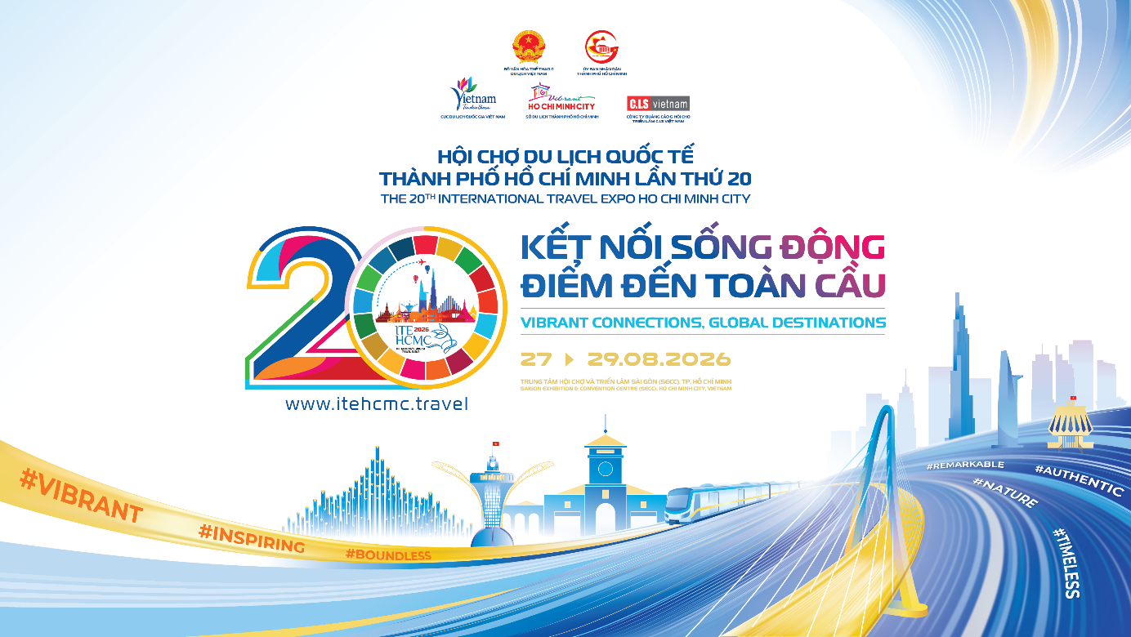
ACKNOWLEDGING THE SUPPORT OF SPONSORS AND PARTNERS
Through proactive engagement, outreach and efforts to mobilize support from the business community, the Organizing Committee of the 20th Ho Chi Minh City International Travel Expo (ITE HCMC 2026) has received valuable support, sponsorship and contributions from numerous organizations and businesses.
This support not only contributes to enhancing the quality and professionalism of the Expo, but also reflects a shared commitment to advancing tourism in Ho Chi Minh City and Vietnam in a professional, modern and internationally integrated direction.
The Organizing Committee sincerely acknowledges and appreciates the invaluable support of the following sponsors:
I. DIAMOND SPONSORS:
- Airports Corporation of Vietnam - JSC (ACV)
- Nhi Minh Long Red Reishi Mushroom Company
- Saigontourist Group
- Vietnam Airlines - JSC
- GEM Center
II. GOLD SPONSORS:
- Grand Hotel
- Rex Hotel
- Saigon Exhibition and Convention Center (SECC)
- The Grand Ho Tram
- Majestic Hotel
- Turkish Airlines
III. SILVER SPONSORS:
  - Green and Smart Mobility Joint Stock Company (GSM)
  - Emirates
  - T-Ritz International Joint Stock Company (T-Ritz Hotel)
  - BM Production - Trading - Services Company Limited (BM Wine)
  - Sofitel Saigon Plaza
  - BT Tour Community Tourism and Event Organization Company Limited
  - Phuc Dien Development Investment Joint Stock Company - Wink Saigon Centre
  - Loa Loa Culture and Cuisine Joint Stock Company
  - Saigon Indochine Cruise Joint Stock Company
  - Foody Corporation (ShopeeFood)

IV. BRONZE SPONSORS:
  - Vietjet Aviation Joint Stock Company (Vietjet Air)
  - Ho Chi Minh City Art Center
  - Mai House Hospitality Vietnam Joint Stock Company (Mai House Saigon Hotel)
  - Kim Do Hotel (Royal Hotel Saigon)
  - Saigon Riverside Hotel Joint Venture Company (Renaissance Riverside Saigon Hotel)
  - KiN Group Hotel
  - Chains Caravelle Hotel Limited Joint Venture Company (Caravelle Saigon)
  - Saigon Inn Hotel Joint Venture Company (New World Saigon Hotel)
  - FEI-YUEH Vietnam Joint Stock Company (Nikko Saigon Hotel)
  - Liberty Central Saigon Riverside Hotel – Que Huong Liberty Joint Stock Company
  - PR Newswire Asia Limited
  - EVA Air
  - Lao Phu Food Trading Services Joint Stock Company
  - Sun Group
  - Pho Museum

V. SUPPORTING PARTNERS:
  - Liberty Central Saigon Centre Hotel – Que Huong Liberty Joint Stock Company
  - Ban Me Gold Company Limited
  - Continental Hotel Saigon
  - La’artisan Joint Stock Company
  - Qingdao Airlines
  - Hotel Equatorial Ho Chi Minh City
  - Oscar Saigon Hotel
  - Vinametric Company Limited – Saigon Prince Hotel
  - Ocany Vietnam Joint Venture Company Limited
  - Windsor Plaza Hotel – An Dong Investment and Development Group Joint Stock Company
  - Harmony Crochet Household Business
  - MobiFone Ho Chi Minh City

*EVENT ORGANIZATION PARTNER - C.I.S Vietnam Advertising & Exhibition Joint Stock Company
C.I.S Vietnam Advertising & Exhibition Joint Stock Company is one of Vietnam’s leading professional event, trade fair and exhibition organizers. Over the years, C.I.S Vietnam has worked closely with the Vietnam National Authority of Tourism and the Ho Chi Minh City Department of Tourism as the Event Organization Partner of ITE HCMC.
With its professional event management capabilities and in-depth understanding of the tourism market, C.I.S Vietnam has worked alongside ITE HCMC through numerous successful editions – from the challenging period of rebuilding after the COVID-19 pandemic to the milestone 20th edition of ITE HCMC 2026.
Its contributions span a wide range of areas, including event operations, exhibition space design and construction, logistics, international delegation reception and hospitality, and coordination of the Hosted Buyers Programme. C.I.S Vietnam has also demonstrated continued flexibility in adapting the Expo model to global trends, from hybrid exhibition formats combining on-site and online participation to the application of AI-powered technologies in B2B business matching and networking.

MEDIA GUIDANCE FOR PRESS AND MEDIA OUTLETS

1. COMMUNICATION THEME

“Vibrant Connections – Global Destinations”

2. KEY MESSAGE
ITE HCMC 2026 marks the 20-year journey of the Ho Chi Minh City International Travel Expo, reaffirming its role as one of Vietnam’s leading platforms for international tourism trade promotion and cooperation. Under the theme “Vibrant Connections – Global Destinations,” the Expo goes beyond connecting businesses with markets. It connects policy with practice, technology with innovation, destinations with international partners, and tourism with the community – contributing to strengthening the position of Ho Chi Minh City and Vietnam on the regional and global tourism map.

3. KEY COMMUNICATION KEYWORDS
ITE HCMC 2026 · Vibrant Connections – Global Destinations · Ho Chi Minh City International Travel Expo · B2B Meetings· Hosted Buyers · Tourism diplomacy · Mekong subregional cooperation · MICE tourism · Artificial Intelligence (AI) in tourism · Destination brand management · Medical tourism · TravelTech startups · Sustainable tourism · Digital transformation in tourism · High-value international visitors · Consumer Day

4. KEY HIGHLIGHTS & FIGURES
- 20 years of ITE HCMC
- More than 500 exhibitors and brands
- 34 Vietnamese provinces and cities participating
- 260 high-level international buyers (Hosted Buyers)
- Participants from 32 countries and territories
- Expected 30,000+ visitors
- Approximately 60 international trade magazines, content creators and international media partners
- Three Mekong subregional Tourism Ministers’ Meetings – CLV, ACMECS and CLMV
- 21,000+ pre-scheduled B2B appointments

5. SUGGESTED MEDIA ANGLES
- ITE HCMC 2026 – 20 years of growth and a new chapter for the Ho Chi Minh City International Travel Expo.
- For the first time, three Mekong subregional Tourism Ministers’ Meetings – CLV, ACMECS and CLMV – convene within the framework of an international travel expo in Ho Chi Minh City.
- Artificial Intelligence (AI) in tourism: Emerging trends and growth opportunities highlighted at ITE HCMC 2026.
- Destination brand management in an increasingly competitive global market: Insights from international experts and organizations.
- MICE tourism – A driver of competitiveness and international event attraction for Vietnam.
- TravelTech startups: Connecting innovation ecosystems with international investment and business opportunities.
- ITE HCMC 2026 – A public-facing tourism experience supporting domestic travel demand and destination promotion.
- Hosted Buyers Programme – A distinctive value that has shaped the ITE HCMC brand over two decades.
- ITE HCMC 2026’s international communications campaign: Bringing the story of Ho Chi Minh City and Vietnam tourism to global audiences.

6. RECOMMENDED HASHTAGS
#ITEHCMC2026
#VibrantConnections
#GlobalDestinations
#KetNoiSongDong
#DiemDenToanCau
#VibrantHoChiMinhCity
#DuLichTPHCM

7. NOTE
The programs, activities and figures presented in this document may be adjusted based on actual developments. The Organizing Committee will provide official updates to press and media outlets ahead of the Expo’s opening.

PRESS INFORMATION
About the Ho Chi Minh City International Travel Expo (ITE HCMC)
The Ho Chi Minh City International Travel Expo (ITE HCMC) is an annual international tourism trade promotion event held under the direction of the Ministry of Culture, Sports and Tourism and the People’s Committee of Ho Chi Minh City. The Expo is led by the Ho Chi Minh City Department of Tourism, in coordination with the Vietnam National Authority of Tourism and relevant agencies and organizations.
First held in 2005, ITE HCMC has established itself as a pioneering international tourism trade event in Vietnam, distinguished by its professionally organized and high-quality Hosted Buyers Programme, which brings together strategic partners from key international markets.
The Expo has not only enhanced the scale and stature of the event, but has also helped shape market development trends, expand business opportunities and increase the effectiveness of international tourism promotion. It provides a direct platform for Vietnamese tourism businesses to connect with international buyers, tourism promotion organizations, airlines, accommodation providers, investors and partners across the global tourism value chain.
In 2026, the Expo will take place from 27–29 August 2026 at the Saigon Exhibition and Convention Center (SECC) in Ho Chi Minh City, under the theme “Vibrant Connections – Global Destinations.” The 20th edition is expected to bring together more than 500 businesses and brands from more than 40 countries and territories, alongside 34 provinces and cities across Vietnam.
📌 Official Press Materials
Official press releases and images from the 20th Ho Chi Minh City International Travel Expo (ITE HCMC 2026) are available at the following link and QR code:
ITE HCMC 2026 – Official Press Materials
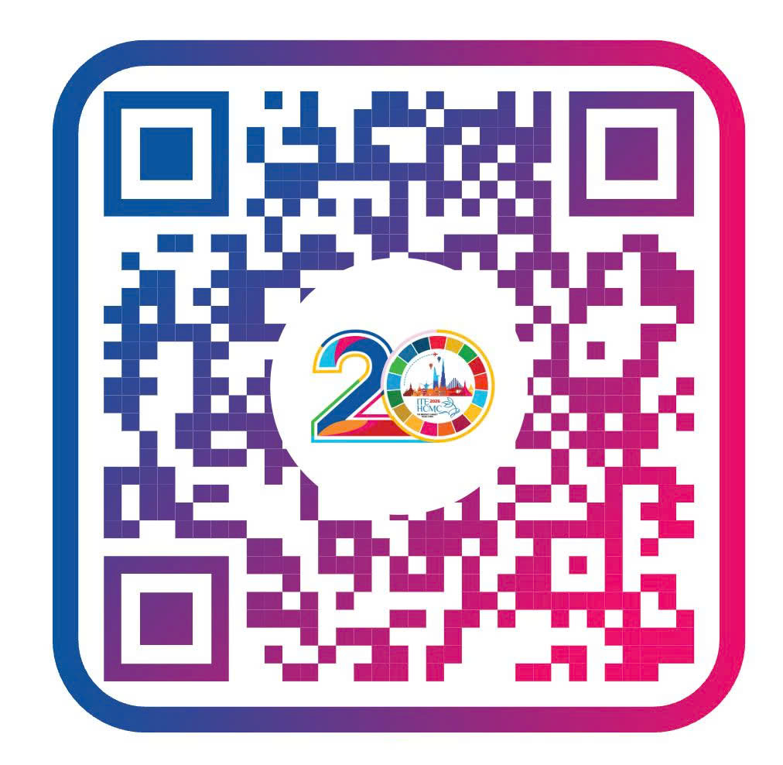

Official Information Channels
Ho Chi Minh City Tourism
- Website – Visit Ho Chi Minh City
- Facebook – Vibrant Ho Chi Minh City
- Instagram – Vibrant Ho Chi Minh City
- TikTok – Vibrant Ho Chi Minh City
- YouTube – Vibrant Ho Chi Minh City
Ho Chi Minh City International Travel Expo (ITE HCMC)
- ITE HCMC Official Website
- ITE HCMC Official Facebook
Media Contact
Ms. Duong Thi Hoang Yen
Deputy Head, Promotion Services Division
Ho Chi Minh City Tourism Promotion Center
Ho Chi Minh City Department of Tourism
Mobile: 0903 699 799
Email: dthyen.sdl@tphcm.gov.vn

